NOTES – MySQL Workbench

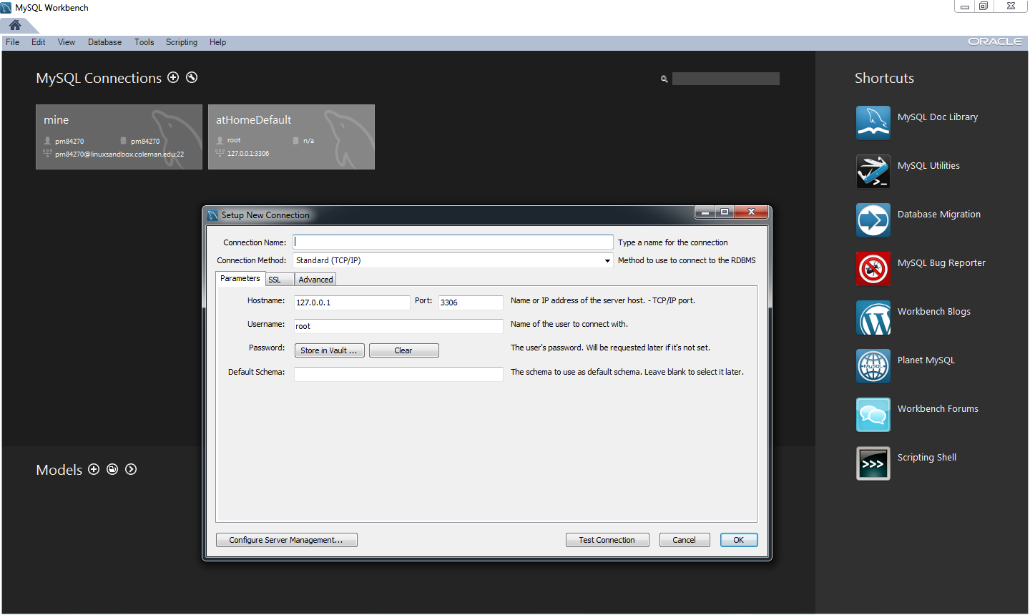

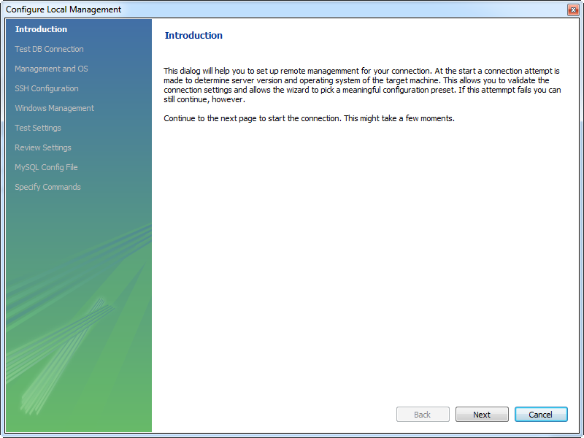

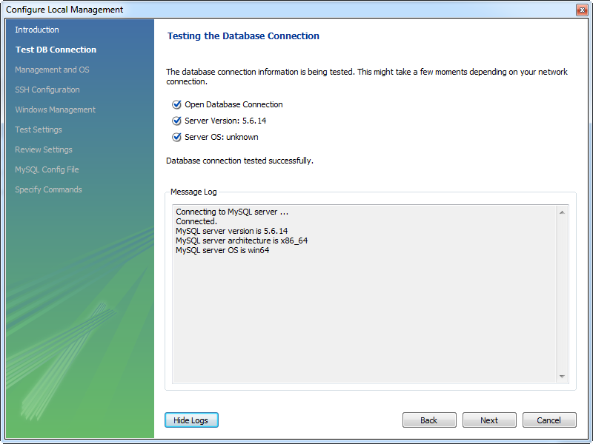

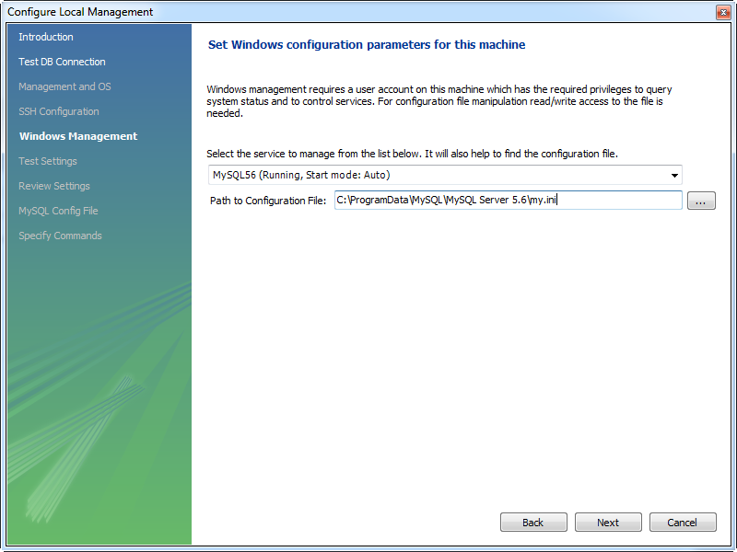

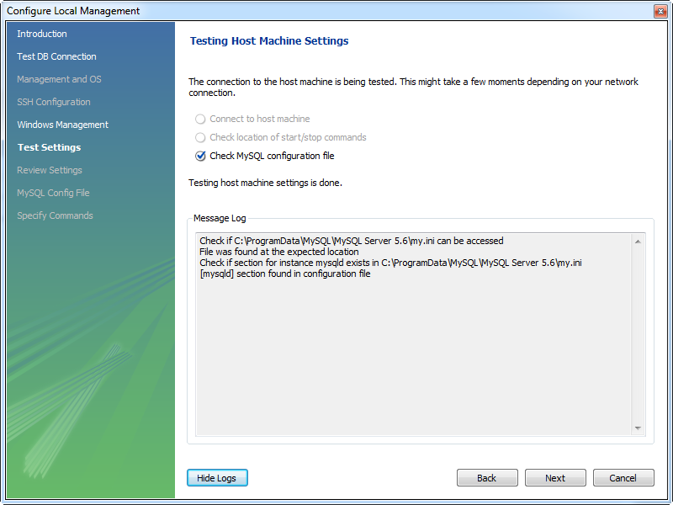

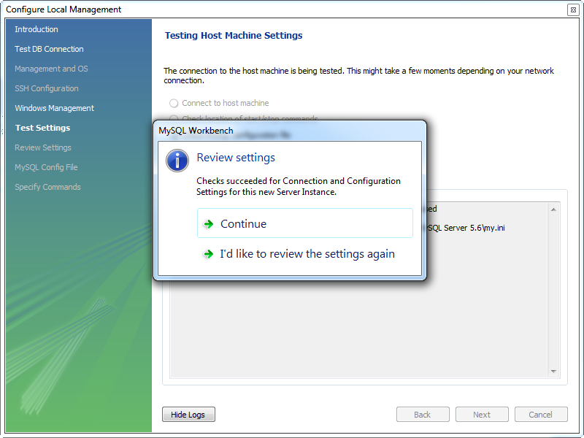

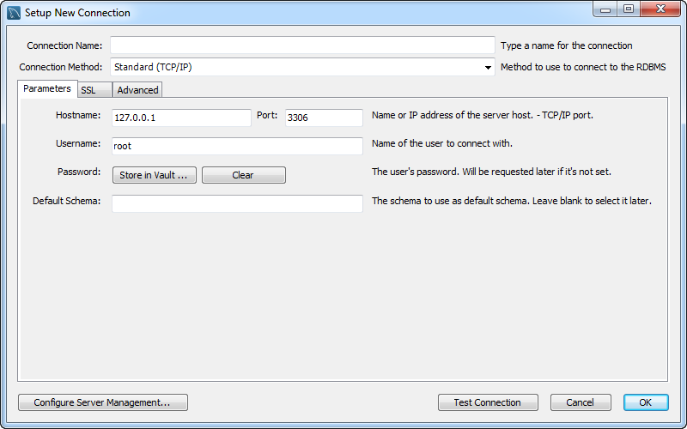

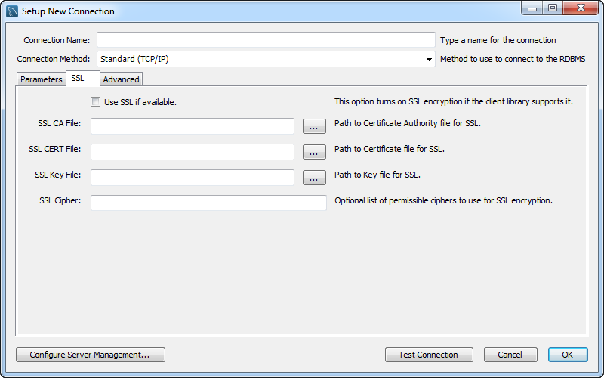

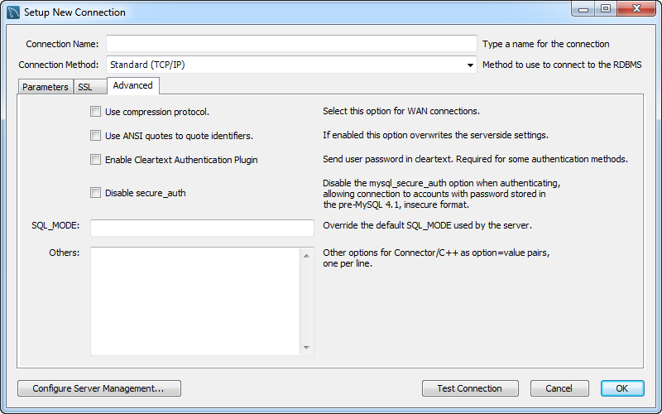

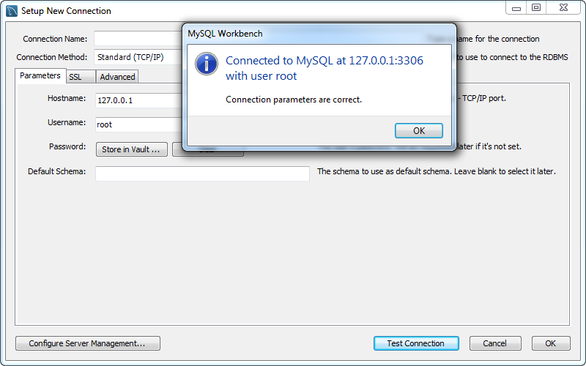

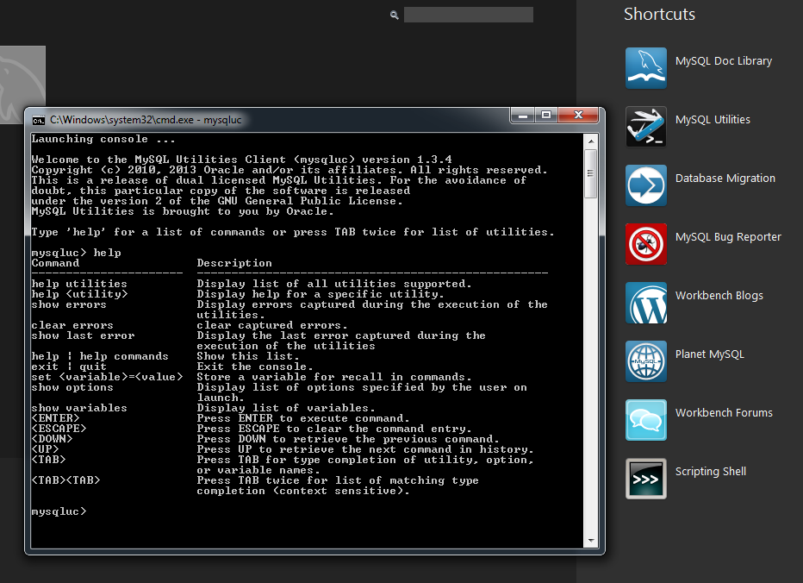

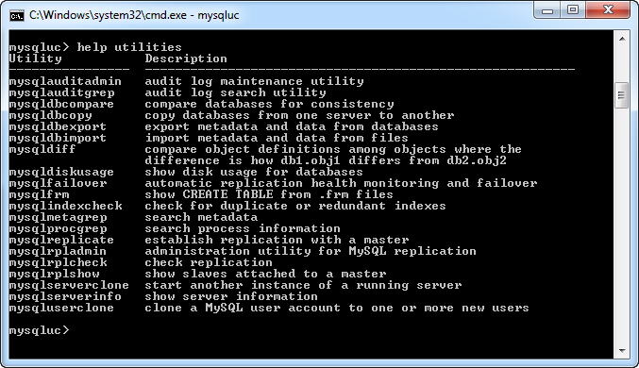

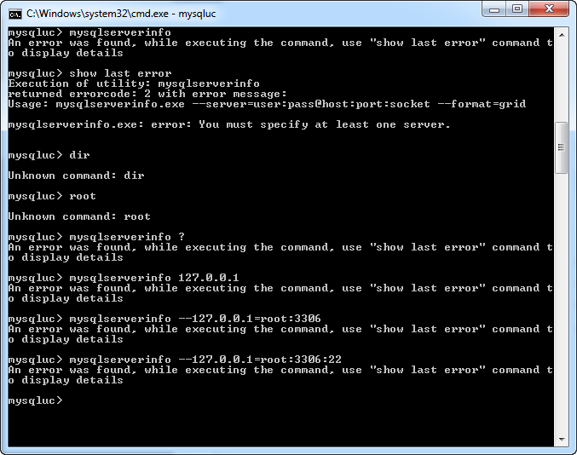

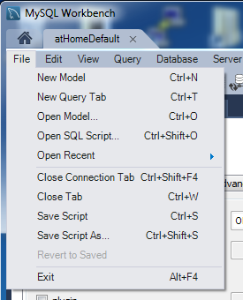 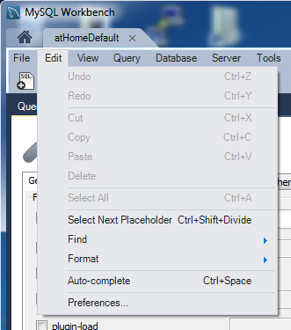

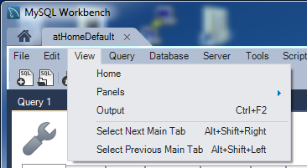 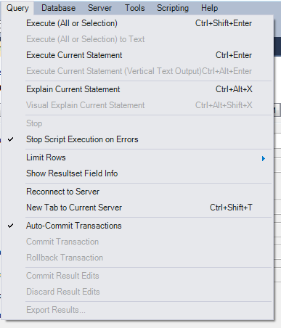

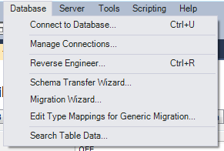 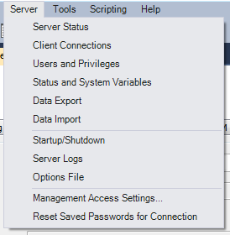

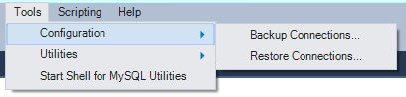

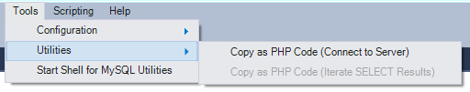

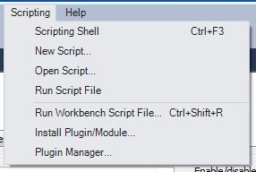 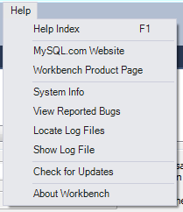

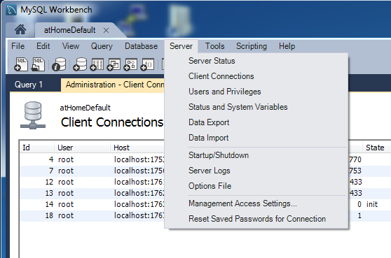

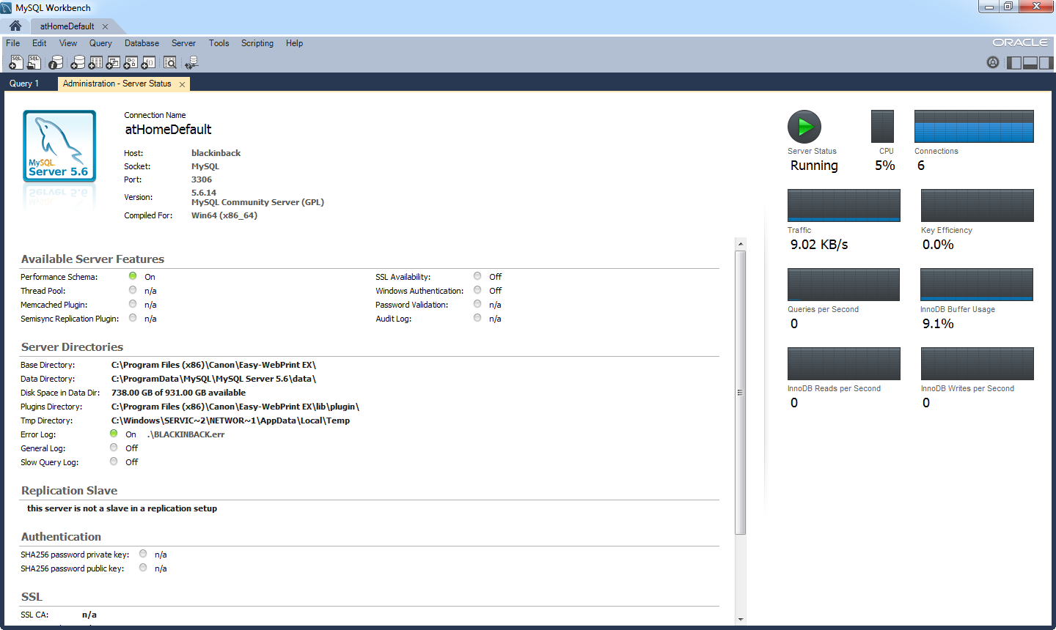

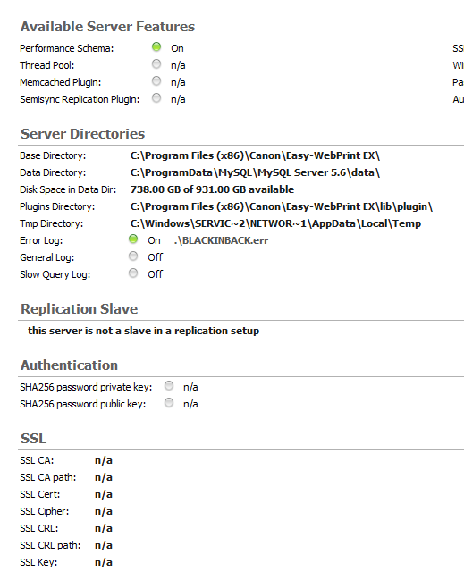

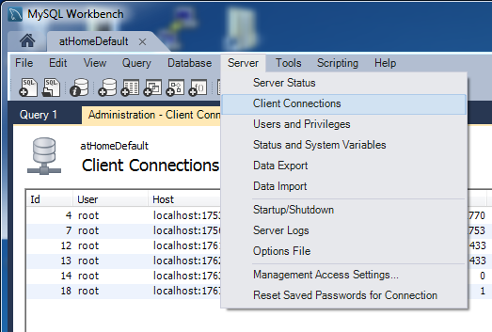

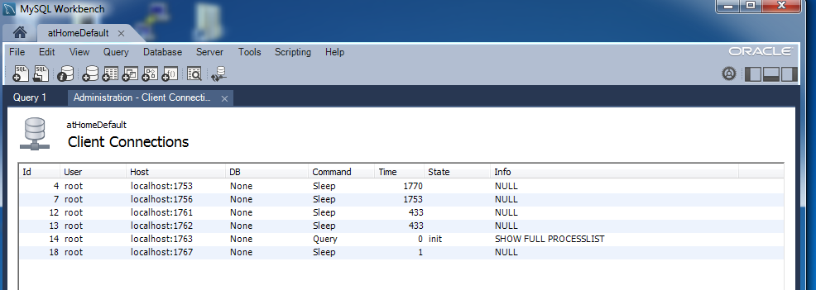

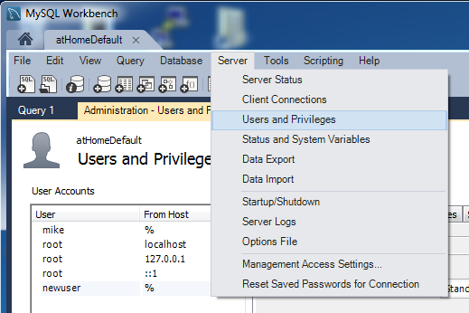

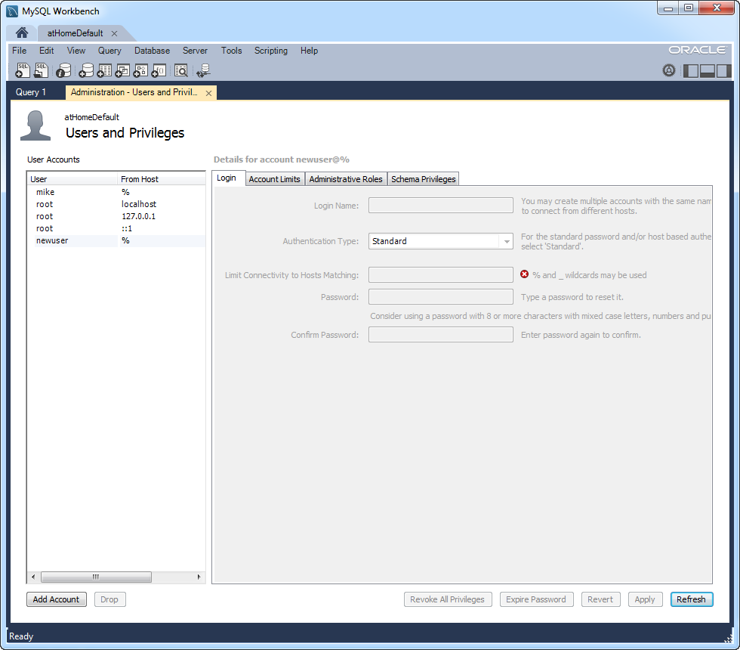

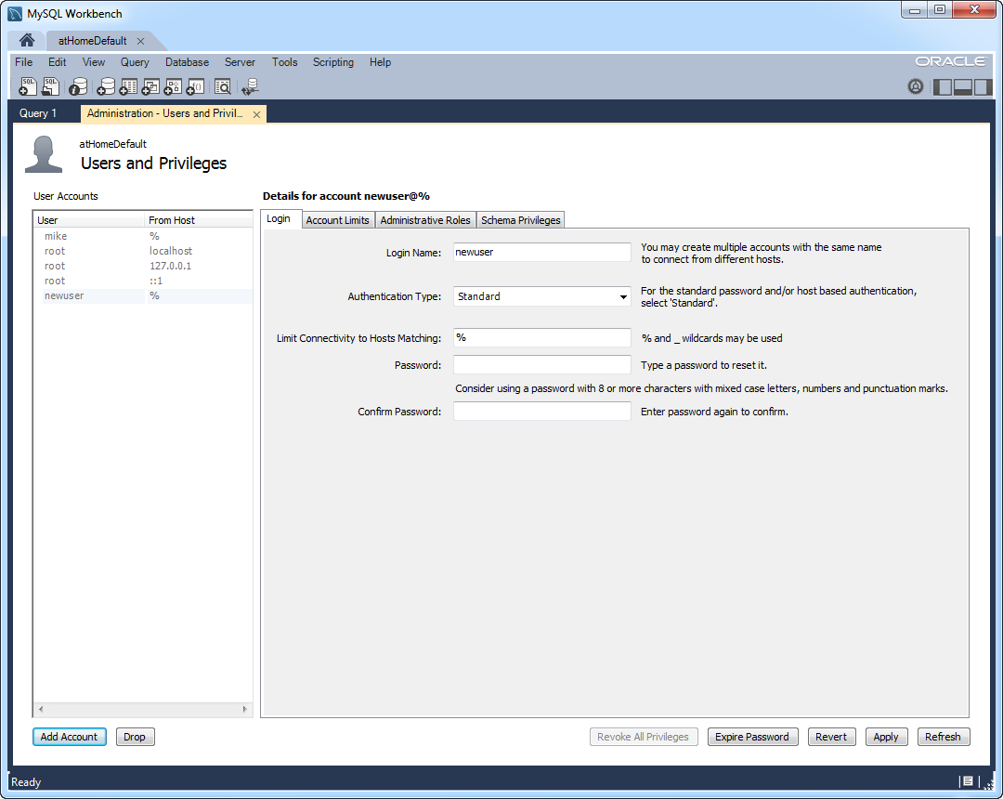

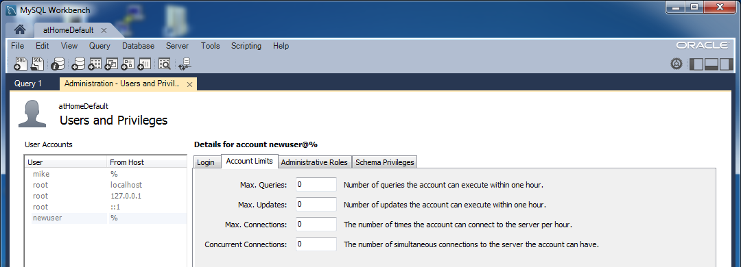

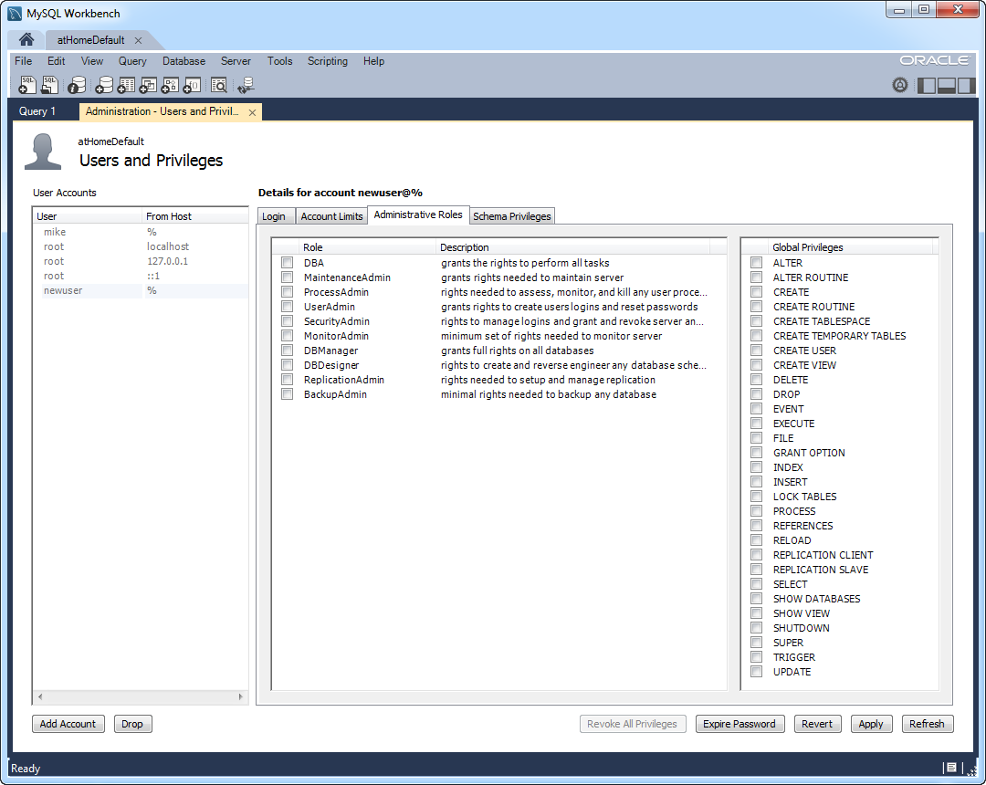

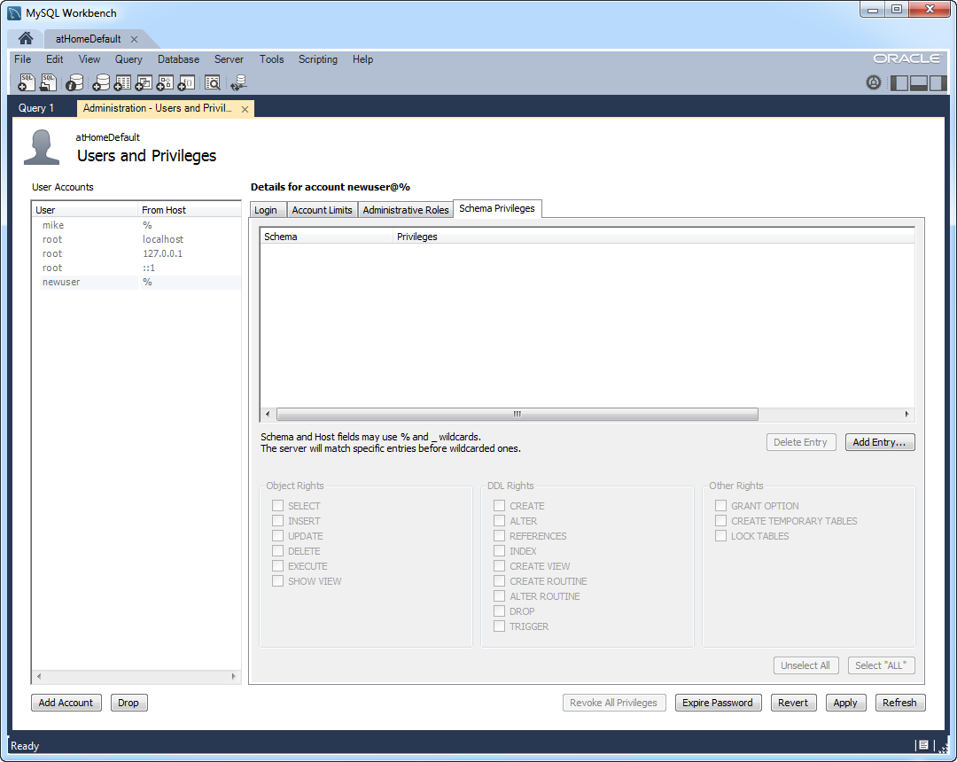

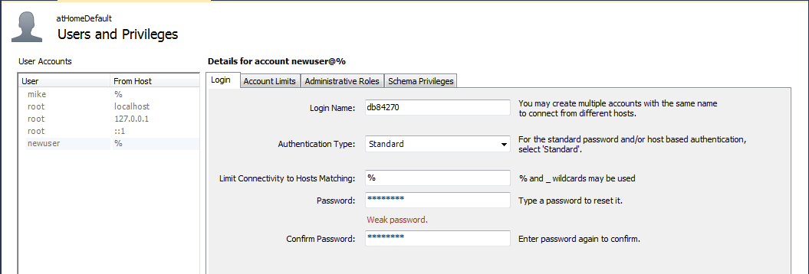

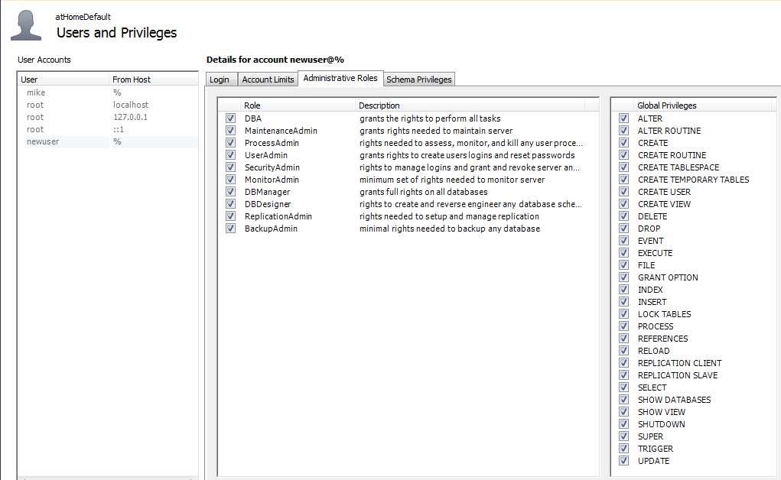

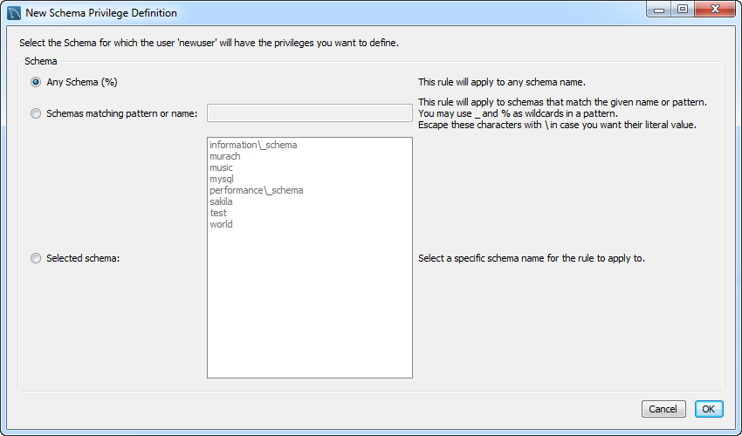

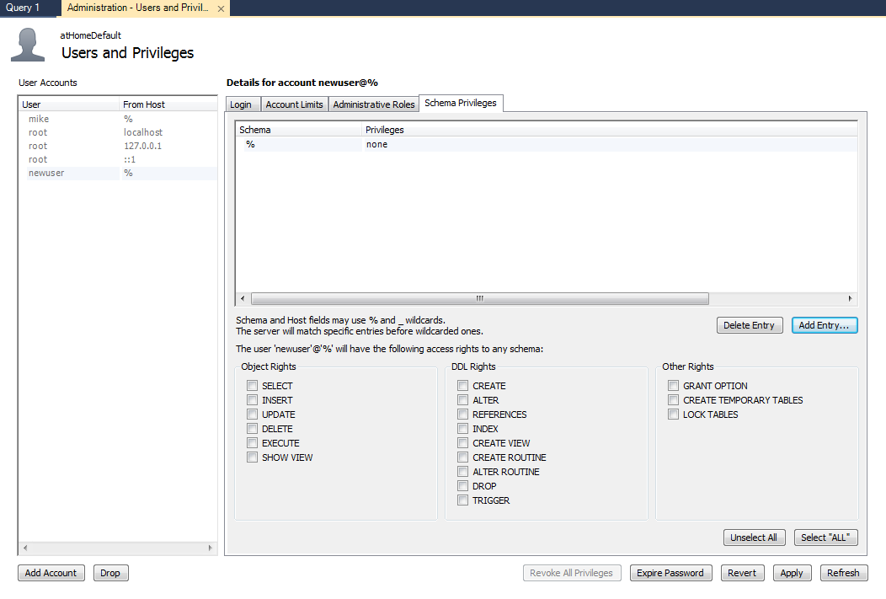

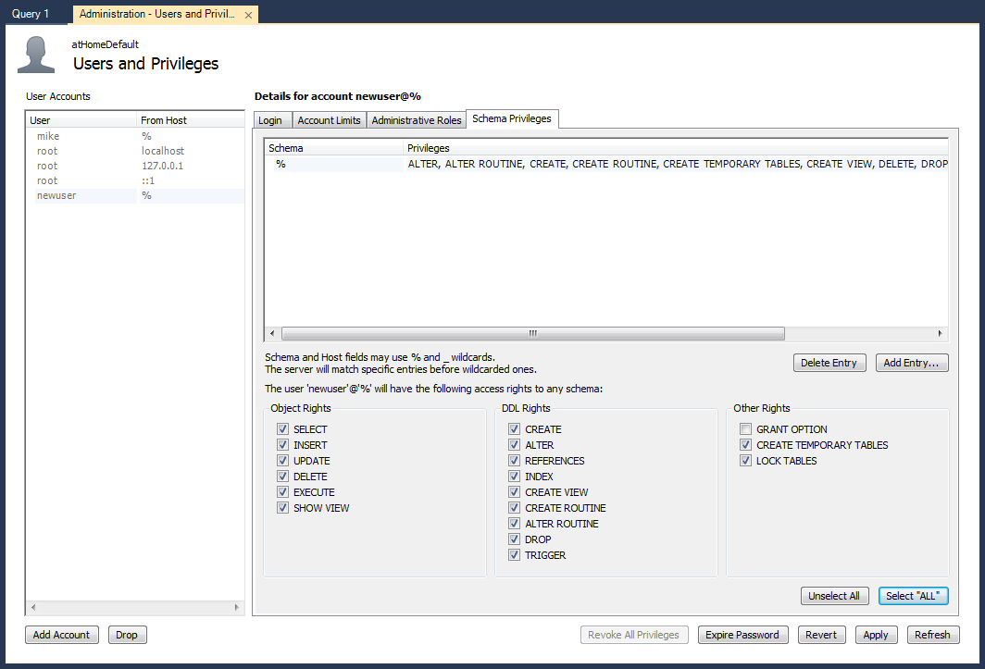

GLOBAL STATUS:

Aborted_clients............................................ 0

Aborted_connects........................................... 3

Binlog_cache_disk_use...................................... 0

Binlog_cache_use........................................... 0

Binlog_stmt_cache_disk_use................................. 0

Binlog_stmt_cache_use...................................... 0

Bytes_received............................................. 28280

Bytes_sent................................................. 7699335

Com_admin_commands......................................... 17

Com_assign_to_keycache..................................... 0

Com_alter_db............................................... 0

Com_alter_db_upgrade....................................... 0

Com_alter_event............................................ 0

Com_alter_function......................................... 0

Com_alter_procedure........................................ 0

Com_alter_server........................................... 0

Com_alter_table............................................ 0

Com_alter_tablespace....................................... 0

Com_alter_user............................................. 0

Com_analyze................................................ 0

Com_begin.................................................. 0

Com_binlog................................................. 0

Com_call_procedure......................................... 0

Com_change_db.............................................. 2

Com_change_master.......................................... 0

Com_check.................................................. 0

Com_checksum............................................... 0

Com_commit................................................. 0

Com_create_db.............................................. 0

Com_create_event........................................... 0

Com_create_function........................................ 0

Com_create_index........................................... 0

Com_create_procedure....................................... 0

Com_create_server.......................................... 0

Com_create_table........................................... 0

Com_create_trigger......................................... 0

Com_create_udf............................................. 0

Com_create_user............................................ 1

Com_create_view............................................ 0

Com_dealloc_sql............................................ 0

Com_delete................................................. 0

Com_delete_multi........................................... 0

Com_do..................................................... 0

Com_drop_db................................................ 0

Com_drop_event............................................. 0

Com_drop_function.......................................... 0

Com_drop_index............................................. 0

Com_drop_procedure......................................... 0

Com_drop_server............................................ 0

Com_drop_table............................................. 0

Com_drop_trigger........................................... 0

Com_drop_user.............................................. 0

Com_drop_view.............................................. 0

Com_empty_query............................................ 0

Com_execute_sql............................................ 0

Com_flush.................................................. 0

Com_get_diagnostics........................................ 0

Com_grant.................................................. 2

Com_ha_close............................................... 0

Com_ha_open................................................ 0

Com_ha_read................................................ 0

Com_help................................................... 0

Com_insert................................................. 0

Com_insert_select.......................................... 0

Com_install_plugin......................................... 0

Com_kill................................................... 0

Com_load................................................... 0

Com_lock_tables............................................ 0

Com_optimize............................................... 0

Com_preload_keys........................................... 0

Com_prepare_sql............................................ 0

Com_purge.................................................. 0

Com_purge_before_date...................................... 0

Com_release_savepoint...................................... 0

Com_rename_table........................................... 0

Com_rename_user............................................ 0

Com_repair................................................. 0

Com_replace................................................ 0

Com_replace_select......................................... 0

Com_reset.................................................. 0

Com_resignal............................................... 0

Com_revoke................................................. 1

Com_revoke_all............................................. 0

Com_rollback............................................... 0

Com_rollback_to_savepoint.................................. 0

Com_savepoint.............................................. 0

Com_select................................................. 38

Com_set_option............................................. 58

Com_signal................................................. 0

Com_show_binlog_events..................................... 0

Com_show_binlogs........................................... 0

Com_show_charsets.......................................... 0

Com_show_collations........................................ 0

Com_show_create_db......................................... 0

Com_show_create_event...................................... 0

Com_show_create_func....................................... 0

Com_show_create_proc....................................... 0

Com_show_create_table...................................... 0

Com_show_create_trigger.................................... 0

Com_show_databases......................................... 9

Com_show_engine_logs....................................... 0

Com_show_engine_mutex...................................... 0

Com_show_engine_status..................................... 0

Com_show_events............................................ 0

Com_show_errors............................................ 0

Com_show_fields............................................ 4

Com_show_function_code..................................... 0

Com_show_function_status................................... 0

Com_show_grants............................................ 0

Com_show_keys.............................................. 0

Com_show_master_status..................................... 0

Com_show_open_tables....................................... 0

Com_show_plugins........................................... 1

Com_show_privileges........................................ 0

Com_show_procedure_code.................................... 0

Com_show_procedure_status.................................. 0

Com_show_processlist....................................... 1

Com_show_profile........................................... 0

Com_show_profiles.......................................... 0

Com_show_relaylog_events................................... 0

Com_show_slave_hosts....................................... 0

Com_show_slave_status...................................... 3

Com_show_status............................................ 826

Com_show_storage_engines................................... 0

Com_show_table_status...................................... 0

Com_show_tables............................................ 0

Com_show_triggers.......................................... 0

Com_show_variables......................................... 26

Com_show_warnings.......................................... 0

Com_slave_start............................................ 0

Com_slave_stop............................................. 0

Com_stmt_close............................................. 0

Com_stmt_execute........................................... 0

Com_stmt_fetch............................................. 0

Com_stmt_prepare........................................... 0

Com_stmt_reprepare......................................... 0

Com_stmt_reset............................................. 0

Com_stmt_send_long_data.................................... 0

Com_truncate............................................... 0

Com_uninstall_plugin....................................... 0

Com_unlock_tables.......................................... 0

Com_update................................................. 0

Com_update_multi........................................... 0

Com_xa_commit.............................................. 0

Com_xa_end................................................. 0

Com_xa_prepare............................................. 0

Com_xa_recover............................................. 0

Com_xa_rollback............................................ 0

Com_xa_start............................................... 0

Compression................................................ OFF

Connection_errors_accept................................... 0

Connection_errors_internal................................. 0

Connection_errors_max_connections.......................... 0

Connection_errors_peer_address............................. 0

Connection_errors_select................................... 0

Connection_errors_tcpwrap.................................. 0

Connections................................................ 21

Created_tmp_disk_tables.................................... 5

Created_tmp_files.......................................... 5

Created_tmp_tables......................................... 866

Delayed_errors............................................. 0

Delayed_insert_threads..................................... 0

Delayed_writes............................................. 0

Flush_commands............................................. 1

Handler_commit............................................. 0

Handler_delete............................................. 0

Handler_discover........................................... 0

Handler_external_lock...................................... 184

Handler_mrr_init........................................... 0

Handler_prepare............................................ 0

Handler_read_first......................................... 5

Handler_read_key........................................... 12

Handler_read_last.......................................... 0

Handler_read_next.......................................... 2

Handler_read_prev.......................................... 0

Handler_read_rnd........................................... 0

Handler_read_rnd_next...................................... 283369

Handler_rollback........................................... 0

Handler_savepoint.......................................... 0

Handler_savepoint_rollback................................. 0

Handler_update............................................. 2

Handler_write.............................................. 282466

Innodb_buffer_pool_dump_status............................. not started

Innodb_buffer_pool_load_status............................. not started

Innodb_buffer_pool_pages_data.............................. 402

Innodb_buffer_pool_bytes_data.............................. 6586368

Innodb_buffer_pool_pages_dirty............................. 0

Innodb_buffer_pool_bytes_dirty............................. 0

Innodb_buffer_pool_pages_flushed........................... 1

Innodb_buffer_pool_pages_free.............................. 4014

Innodb_buffer_pool_pages_misc.............................. 0

Innodb_buffer_pool_pages_total............................. 4416

Innodb_buffer_pool_read_ahead_rnd.......................... 0

Innodb_buffer_pool_read_ahead.............................. 0

Innodb_buffer_pool_read_ahead_evicted...................... 0

Innodb_buffer_pool_read_requests........................... 3586

Innodb_buffer_pool_reads................................... 403

Innodb_buffer_pool_wait_free............................... 0

Innodb_buffer_pool_write_requests.......................... 1

Innodb_data_fsyncs......................................... 5

Innodb_data_pending_fsyncs................................. 0

Innodb_data_pending_reads.................................. 0

Innodb_data_pending_writes................................. 0

Innodb_data_read........................................... 8785920

Innodb_data_reads.......................................... 415

Innodb_data_writes......................................... 5

Innodb_data_written........................................ 34304

Innodb_dblwr_pages_written................................. 1

Innodb_dblwr_writes........................................ 1

Innodb_have_atomic_builtins................................ ON

Innodb_log_waits........................................... 0

Innodb_log_write_requests.................................. 0

Innodb_log_writes.......................................... 1

Innodb_os_log_fsyncs....................................... 3

Innodb_os_log_pending_fsyncs............................... 0

Innodb_os_log_pending_writes............................... 0

Innodb_os_log_written...................................... 512

Innodb_page_size........................................... 16384

Innodb_pages_created....................................... 0

Innodb_pages_read.......................................... 402

Innodb_pages_written....................................... 1

Innodb_row_lock_current_waits.............................. 0

Innodb_row_lock_time....................................... 0

Innodb_row_lock_time_avg................................... 0

Innodb_row_lock_time_max................................... 0

Innodb_row_lock_waits...................................... 0

Innodb_rows_deleted........................................ 0

Innodb_rows_inserted....................................... 0

Innodb_rows_read........................................... 0

Innodb_rows_updated........................................ 0

Innodb_num_open_files...................................... 5

Innodb_truncated_status_writes............................. 0

Innodb_available_undo_logs................................. 128

Key_blocks_not_flushed..................................... 0

Key_blocks_unused.......................................... 6694

Key_blocks_used............................................ 4

Key_read_requests.......................................... 32

Key_reads.................................................. 4

Key_write_requests......................................... 4

Key_writes................................................. 4

Last_query_cost............................................ 0.000000

Last_query_partial_plans................................... 0

Max_used_connections....................................... 6

Not_flushed_delayed_rows................................... 0

Open_files................................................. 16

Open_streams............................................... 0

Open_table_definitions..................................... 67

Open_tables................................................ 60

Opened_files............................................... 134

Opened_table_definitions................................... 67

Opened_tables.............................................. 67

Performance_schema_accounts_lost........................... 0

Performance_schema_cond_classes_lost....................... 0

Performance_schema_cond_instances_lost..................... 0

Performance_schema_digest_lost............................. 0

Performance_schema_file_classes_lost....................... 0

Performance_schema_file_handles_lost....................... 0

Performance_schema_file_instances_lost..................... 0

Performance_schema_hosts_lost.............................. 0

Performance_schema_locker_lost............................. 0

Performance_schema_mutex_classes_lost...................... 0

Performance_schema_mutex_instances_lost.................... 0

Performance_schema_rwlock_classes_lost..................... 0

Performance_schema_rwlock_instances_lost................... 0

Performance_schema_session_connect_attrs_lost.............. 0

Performance_schema_socket_classes_lost..................... 0

Performance_schema_socket_instances_lost................... 0

Performance_schema_stage_classes_lost...................... 0

Performance_schema_statement_classes_lost.................. 0

Performance_schema_table_handles_lost...................... 0

Performance_schema_table_instances_lost.................... 0

Performance_schema_thread_classes_lost..................... 0

Performance_schema_thread_instances_lost................... 0

Performance_schema_users_lost.............................. 0

Prepared_stmt_count........................................ 0

Qcache_free_blocks......................................... 0

Qcache_free_memory......................................... 0

Qcache_hits................................................ 0

Qcache_inserts............................................. 0

Qcache_lowmem_prunes....................................... 0

Qcache_not_cached.......................................... 0

Qcache_queries_in_cache.................................... 0

Qcache_total_blocks........................................ 0

Queries.................................................... 1001

Questions.................................................. 983

Select_full_join........................................... 0

Select_full_range_join..................................... 0

Select_range............................................... 0

Select_range_check......................................... 0

Select_scan................................................ 869

Slave_heartbeat_period.....................................

Slave_last_heartbeat.......................................

Slave_open_temp_tables..................................... 0

Slave_received_heartbeats..................................

Slave_retried_transactions.................................

Slave_running.............................................. OFF

Slow_launch_threads........................................ 0

Slow_queries............................................... 0

Sort_merge_passes.......................................... 0

Sort_range................................................. 2

Sort_rows.................................................. 15

Sort_scan.................................................. 3

Ssl_accept_renegotiates.................................... 0

Ssl_accepts................................................ 0

Ssl_callback_cache_hits.................................... 0

Ssl_cipher.................................................

Ssl_cipher_list............................................

Ssl_client_connects........................................ 0

Ssl_connect_renegotiates................................... 0

Ssl_ctx_verify_depth....................................... 0

Ssl_ctx_verify_mode........................................ 0

Ssl_default_timeout........................................ 0

Ssl_finished_accepts....................................... 0

Ssl_finished_connects...................................... 0

Ssl_server_not_after.......................................

Ssl_server_not_before......................................

Ssl_session_cache_hits..................................... 0

Ssl_session_cache_misses................................... 0

Ssl_session_cache_mode..................................... NONE

Ssl_session_cache_overflows................................ 0

Ssl_session_cache_size..................................... 0

Ssl_session_cache_timeouts................................. 0

Ssl_sessions_reused........................................ 0

Ssl_used_session_cache_entries............................. 0

Ssl_verify_depth........................................... 0

Ssl_verify_mode............................................ 0

Ssl_version................................................

Table_locks_immediate...................................... 92

Table_locks_waited......................................... 0

Table_open_cache_hits...................................... 29

Table_open_cache_misses.................................... 67

Table_open_cache_overflows................................. 0

Tc_log_max_pages_used...................................... 0

Tc_log_page_size........................................... 0

Tc_log_page_waits.......................................... 0

Threads_cached............................................. 0

Threads_connected.......................................... 6

Threads_created............................................ 6

Threads_running............................................ 1

Uptime..................................................... 8920

Uptime_since_flush_status.................................. 8920

GLOBAL VARIABLES:

auto_increment_increment................................... 1

auto_increment_offset...................................... 1

autocommit................................................. ON

automatic_sp_privileges.................................... ON

back_log................................................... 70

basedir.................................................... C:\Program Files (x86)\Canon\Easy-WebPrint EX\

big_tables................................................. OFF

bind_address............................................... *

binlog_cache_size.......................................... 32768

binlog_checksum............................................ CRC32

binlog_direct_non_transactional_updates.................... OFF

binlog_format.............................................. STATEMENT

binlog_max_flush_queue_time................................ 0

binlog_order_commits....................................... ON

binlog_row_image........................................... FULL

binlog_rows_query_log_events............................... OFF

binlog_stmt_cache_size..................................... 32768

bulk_insert_buffer_size.................................... 8388608

character_set_client....................................... utf8

character_set_connection................................... utf8

character_set_database..................................... utf8

character_set_filesystem................................... binary

character_set_results...................................... utf8

character_set_server....................................... utf8

character_set_system....................................... utf8

character_sets_dir......................................... C:\Program Files (x86)\Canon\Easy-WebPrint EX\share\charsets\

collation_connection....................................... utf8_general_ci

collation_database......................................... utf8_general_ci

collation_server........................................... utf8_general_ci

completion_type............................................ NO_CHAIN

concurrent_insert.......................................... AUTO

connect_timeout............................................ 10

core_file.................................................. OFF

datadir.................................................... C:\ProgramData\MySQL\MySQL Server 5.6\data\

date_format................................................ %Y-%m-%d

datetime_format............................................ %Y-%m-%d %H:%i:%s

default_storage_engine..................................... InnoDB

default_tmp_storage_engine................................. InnoDB

default_week_format........................................ 0

delay_key_write............................................ ON

delayed_insert_limit....................................... 100

delayed_insert_timeout..................................... 300

delayed_queue_size......................................... 1000

disconnect_on_expired_password............................. ON

div_precision_increment.................................... 4

end_markers_in_json........................................ OFF

enforce_gtid_consistency................................... OFF

eq_range_index_dive_limit.................................. 10

event_scheduler............................................ OFF

expire_logs_days........................................... 0

explicit_defaults_for_timestamp............................ OFF

flush...................................................... OFF

flush_time................................................. 0

foreign_key_checks......................................... ON

ft_boolean_syntax.......................................... + -><()~*:""&|

ft_max_word_len............................................ 84

ft_min_word_len............................................ 4

ft_query_expansion_limit................................... 20

ft_stopword_file........................................... (built-in)

general_log................................................ OFF

general_log_file........................................... BLACKINBACK.log

group_concat_max_len....................................... 1024

gtid_executed..............................................

gtid_mode.................................................. OFF

gtid_owned.................................................

gtid_purged................................................

have_compress.............................................. YES

have_crypt................................................. NO

have_dynamic_loading....................................... YES

have_geometry.............................................. YES

have_openssl............................................... DISABLED

have_profiling............................................. YES

have_query_cache........................................... YES

have_rtree_keys............................................ YES

have_ssl................................................... DISABLED

have_symlink............................................... YES

host_cache_size............................................ 228

hostname................................................... blackinback

ignore_builtin_innodb...................................... OFF

ignore_db_dirs.............................................

init_connect...............................................

init_file..................................................

init_slave.................................................

innodb_adaptive_flushing................................... ON

innodb_adaptive_flushing_lwm............................... 10

innodb_adaptive_hash_index................................. ON

innodb_adaptive_max_sleep_delay............................ 150000

innodb_additional_mem_pool_size............................ 2097152

innodb_api_bk_commit_interval.............................. 5

innodb_api_disable_rowlock................................. OFF

innodb_api_enable_binlog................................... OFF

innodb_api_enable_mdl...................................... OFF

innodb_api_trx_level....................................... 0

innodb_autoextend_increment................................ 1000

innodb_autoinc_lock_mode................................... 1

innodb_buffer_pool_dump_at_shutdown........................ OFF

innodb_buffer_pool_dump_now................................ OFF

innodb_buffer_pool_filename................................ ib_buffer_pool

innodb_buffer_pool_instances............................... 8

innodb_buffer_pool_load_abort.............................. OFF

innodb_buffer_pool_load_at_startup......................... OFF

innodb_buffer_pool_load_now................................ OFF

innodb_buffer_pool_size.................................... 72351744

innodb_change_buffer_max_size.............................. 25

innodb_change_buffering.................................... all

innodb_checksum_algorithm.................................. crc32

innodb_checksums........................................... ON

innodb_cmp_per_index_enabled............................... OFF

innodb_commit_concurrency.................................. 0

innodb_compression_failure_threshold_pct................... 5

innodb_compression_level................................... 6

innodb_compression_pad_pct_max............................. 50

innodb_concurrency_tickets................................. 5000

innodb_data_file_path...................................... ibdata1:12M:autoextend

innodb_data_home_dir.......................................

innodb_disable_sort_file_cache............................. OFF

innodb_doublewrite......................................... ON

innodb_fast_shutdown....................................... 1

innodb_file_format......................................... Antelope

innodb_file_format_check................................... ON

innodb_file_format_max..................................... Antelope

innodb_file_per_table...................................... ON

innodb_flush_log_at_timeout................................ 1

innodb_flush_log_at_trx_commit............................. 1

innodb_flush_method........................................

innodb_flush_neighbors..................................... 1

innodb_flushing_avg_loops.................................. 30

innodb_force_load_corrupted................................ OFF

innodb_force_recovery...................................... 0

innodb_ft_aux_table........................................

innodb_ft_cache_size....................................... 8000000

innodb_ft_enable_diag_print................................ OFF

innodb_ft_enable_stopword.................................. ON

innodb_ft_max_token_size................................... 84

innodb_ft_min_token_size................................... 3

innodb_ft_num_word_optimize................................ 2000

innodb_ft_result_cache_limit............................... 2000000000

innodb_ft_server_stopword_table............................

innodb_ft_sort_pll_degree.................................. 2

innodb_ft_total_cache_size................................. 640000000

innodb_ft_user_stopword_table..............................

innodb_io_capacity......................................... 200

innodb_io_capacity_max..................................... 2000

innodb_large_prefix........................................ OFF

innodb_lock_wait_timeout................................... 50

innodb_locks_unsafe_for_binlog............................. OFF

innodb_log_buffer_size..................................... 1048576

innodb_log_compressed_pages................................ ON

innodb_log_file_size....................................... 50331648

innodb_log_files_in_group.................................. 2

innodb_log_group_home_dir.................................. .\

innodb_lru_scan_depth...................................... 1024

innodb_max_dirty_pages_pct................................. 75

innodb_max_dirty_pages_pct_lwm............................. 0

innodb_max_purge_lag....................................... 0

innodb_max_purge_lag_delay................................. 0

innodb_mirrored_log_groups................................. 1

innodb_monitor_disable.....................................

innodb_monitor_enable......................................

innodb_monitor_reset.......................................

innodb_monitor_reset_all...................................

innodb_old_blocks_pct...................................... 37

innodb_old_blocks_time..................................... 1000

innodb_online_alter_log_max_size........................... 134217728

innodb_open_files.......................................... 300

innodb_optimize_fulltext_only.............................. OFF

innodb_page_size........................................... 16384

innodb_print_all_deadlocks................................. OFF

innodb_purge_batch_size.................................... 300

innodb_purge_threads....................................... 1

innodb_random_read_ahead................................... OFF

innodb_read_ahead_threshold................................ 56

innodb_read_io_threads..................................... 4

innodb_read_only........................................... OFF

innodb_replication_delay................................... 0

innodb_rollback_on_timeout................................. OFF

innodb_rollback_segments................................... 128

innodb_sort_buffer_size.................................... 1048576

innodb_spin_wait_delay..................................... 6

innodb_stats_auto_recalc................................... ON

innodb_stats_method........................................ nulls_equal

innodb_stats_on_metadata................................... OFF

innodb_stats_persistent.................................... ON

innodb_stats_persistent_sample_pages....................... 20

innodb_stats_sample_pages.................................. 8

innodb_stats_transient_sample_pages........................ 8

innodb_strict_mode......................................... OFF

innodb_support_xa.......................................... ON

innodb_sync_array_size..................................... 1

innodb_sync_spin_loops..................................... 30

innodb_table_locks......................................... ON

innodb_thread_concurrency.................................. 9

innodb_thread_sleep_delay.................................. 10000

innodb_undo_directory...................................... .

innodb_undo_logs........................................... 128

innodb_undo_tablespaces.................................... 0

innodb_use_native_aio...................................... ON

innodb_use_sys_malloc...................................... ON

innodb_version............................................. 5.6.14

innodb_write_io_threads.................................... 4

interactive_timeout........................................ 28800

join_buffer_size........................................... 262144

keep_files_on_create....................................... OFF

key_buffer_size............................................ 8388608

key_cache_age_threshold.................................... 300

key_cache_block_size....................................... 1024

key_cache_division_limit................................... 100

large_files_support........................................ ON

large_page_size............................................ 0

large_pages................................................ OFF

lc_messages................................................ en_US

lc_messages_dir............................................ C:\Program Files (x86)\Canon\Easy-WebPrint EX\share\

lc_time_names.............................................. en_US

license.................................................... GPL

local_infile............................................... ON

lock_wait_timeout.......................................... 31536000

log_bin.................................................... OFF

log_bin_basename...........................................

log_bin_index..............................................

log_bin_trust_function_creators............................ OFF

log_bin_use_v1_row_events.................................. OFF

log_error.................................................. .\BLACKINBACK.err

log_output................................................. NONE

log_queries_not_using_indexes.............................. OFF

log_slave_updates.......................................... OFF

log_slow_admin_statements.................................. OFF

log_slow_slave_statements.................................. OFF

log_throttle_queries_not_using_indexes..................... 0

log_warnings............................................... 1

long_query_time............................................ 10.000000

low_priority_updates....................................... OFF

lower_case_file_system..................................... ON

lower_case_table_names..................................... 1

master_info_repository..................................... FILE

master_verify_checksum..................................... OFF

max_allowed_packet......................................... 4194304

max_binlog_cache_size...................................... 18446744073709547520

max_binlog_size............................................ 1073741824

max_binlog_stmt_cache_size................................. 18446744073709547520

max_connect_errors......................................... 100

max_connections............................................ 100

max_delayed_threads........................................ 20

max_error_count............................................ 64

max_heap_table_size........................................ 16777216

max_insert_delayed_threads................................. 20

max_join_size.............................................. 18446744073709551615

max_length_for_sort_data................................... 1024

max_prepared_stmt_count.................................... 16382

max_relay_log_size......................................... 0

max_seeks_for_key.......................................... 4294967295

max_sort_length............................................ 1024

max_sp_recursion_depth..................................... 0

max_tmp_tables............................................. 32

max_user_connections....................................... 0

max_write_lock_count....................................... 4294967295

metadata_locks_cache_size.................................. 1024

metadata_locks_hash_instances.............................. 8

min_examined_row_limit..................................... 0

multi_range_count.......................................... 256

myisam_data_pointer_size................................... 6

myisam_max_sort_file_size.................................. 107374182400

myisam_mmap_size........................................... 18446744073709551615

myisam_recover_options..................................... OFF

myisam_repair_threads...................................... 1

myisam_sort_buffer_size.................................... 32505856

myisam_stats_method........................................ nulls_unequal

myisam_use_mmap............................................ OFF

named_pipe................................................. OFF

net_buffer_length.......................................... 16384

net_read_timeout........................................... 30

net_retry_count............................................ 10

net_write_timeout.......................................... 60

new........................................................ OFF

old........................................................ OFF

old_alter_table............................................ OFF

old_passwords.............................................. 0

open_files_limit........................................... 6158

optimizer_prune_level...................................... 1

optimizer_search_depth..................................... 62

optimizer_switch........................................... index_merge=on,index_merge_union=on,index_merge_sort_union=on,index_merge_intersection=on,engine_condition_pushdown=on,index_condition_pushdown=on,mrr=on,mrr_cost_based=on,block_nested_loop=on,batched_key_access=off,materialization=on,semijoin=on,loosescan=on,firstmatch=on,subquery_materialization_cost_based=on,use_index_extensions=on

optimizer_trace............................................ enabled=off,one_line=off

optimizer_trace_features................................... greedy_search=on,range_optimizer=on,dynamic_range=on,repeated_subselect=on

optimizer_trace_limit...................................... 1

optimizer_trace_max_mem_size............................... 16384

optimizer_trace_offset..................................... -1

performance_schema......................................... ON

performance_schema_accounts_size........................... 100

performance_schema_digests_size............................ 10000

performance_schema_events_stages_history_long_size......... 10000

performance_schema_events_stages_history_size.............. 10

performance_schema_events_statements_history_long_size..... 10000

performance_schema_events_statements_history_size.......... 10

performance_schema_events_waits_history_long_size.......... 10000

performance_schema_events_waits_history_size............... 10

performance_schema_hosts_size.............................. 100

performance_schema_max_cond_classes........................ 80

performance_schema_max_cond_instances...................... 3300

performance_schema_max_file_classes........................ 50

performance_schema_max_file_handles........................ 32768

performance_schema_max_file_instances...................... 6770

performance_schema_max_mutex_classes....................... 200

performance_schema_max_mutex_instances..................... 15600

performance_schema_max_rwlock_classes...................... 30

performance_schema_max_rwlock_instances.................... 9000

performance_schema_max_socket_classes...................... 10

performance_schema_max_socket_instances.................... 220

performance_schema_max_stage_classes....................... 150

performance_schema_max_statement_classes................... 168

performance_schema_max_table_handles....................... 4000

performance_schema_max_table_instances..................... 12500

performance_schema_max_thread_classes...................... 50

performance_schema_max_thread_instances.................... 300

performance_schema_session_connect_attrs_size.............. 512

performance_schema_setup_actors_size....................... 100

performance_schema_setup_objects_size...................... 100

performance_schema_users_size.............................. 100

pid_file................................................... C:\ProgramData\MySQL\MySQL Server 5.6\data\blackinback.pid

plugin_dir................................................. C:\Program Files (x86)\Canon\Easy-WebPrint EX\lib\plugin\

port....................................................... 3306

preload_buffer_size........................................ 32768

profiling.................................................. OFF

profiling_history_size..................................... 15

protocol_version........................................... 10

query_alloc_block_size..................................... 8192

query_cache_limit.......................................... 1048576

query_cache_min_res_unit................................... 4096

query_cache_size........................................... 0

query_cache_type........................................... OFF

query_cache_wlock_invalidate............................... OFF

query_prealloc_size........................................ 8192

range_alloc_block_size..................................... 4096

read_buffer_size........................................... 65536

read_only.................................................. OFF

read_rnd_buffer_size....................................... 262144

relay_log..................................................

relay_log_basename.........................................

relay_log_index............................................

relay_log_info_file........................................ relay-log.info

relay_log_info_repository.................................. FILE

relay_log_purge............................................ ON

relay_log_recovery......................................... OFF

relay_log_space_limit...................................... 0

report_host................................................

report_password............................................

report_port................................................ 3306

report_user................................................

rpl_stop_slave_timeout..................................... 31536000

secure_auth................................................ ON

secure_file_priv...........................................

server_id.................................................. 0

server_id_bits............................................. 32

server_uuid................................................ 67173d6f-5be5-11e3-9a19-f46d047ca9b7

shared_memory.............................................. OFF

shared_memory_base_name.................................... MYSQL

skip_external_locking...................................... ON

skip_name_resolve.......................................... OFF

skip_networking............................................ OFF

skip_show_database......................................... OFF

slave_allow_batching....................................... OFF

slave_checkpoint_group..................................... 512

slave_checkpoint_period.................................... 300

slave_compressed_protocol.................................. OFF

slave_exec_mode............................................ STRICT

slave_load_tmpdir.......................................... C:\Windows\SERVIC~2\NETWOR~1\AppData\Local\Temp

slave_max_allowed_packet................................... 1073741824

slave_net_timeout.......................................... 3600

slave_parallel_workers..................................... 0

slave_pending_jobs_size_max................................ 16777216

slave_rows_search_algorithms............................... TABLE_SCAN,INDEX_SCAN

slave_skip_errors.......................................... OFF

slave_sql_verify_checksum.................................. ON

slave_transaction_retries.................................. 10

slave_type_conversions.....................................

slow_launch_time........................................... 2

slow_query_log............................................. OFF

slow_query_log_file........................................ BLACKINBACK-slow.log

socket..................................................... MySQL

sort_buffer_size........................................... 262144

sql_auto_is_null........................................... OFF

sql_big_selects............................................ ON

sql_buffer_result.......................................... OFF

sql_log_bin................................................ ON

sql_log_off................................................ OFF

sql_mode................................................... STRICT_TRANS_TABLES,NO_AUTO_CREATE_USER,NO_ENGINE_SUBSTITUTION

sql_notes.................................................. ON

sql_quote_show_create...................................... ON

sql_safe_updates........................................... OFF

sql_select_limit........................................... 18446744073709551615

sql_slave_skip_counter..................................... 0

sql_warnings............................................... OFF

ssl_ca.....................................................

ssl_capath.................................................

ssl_cert...................................................

ssl_cipher.................................................

ssl_crl....................................................

ssl_crlpath................................................

ssl_key....................................................

storage_engine............................................. InnoDB

stored_program_cache....................................... 256

sync_binlog................................................ 0

sync_frm................................................... ON

sync_master_info........................................... 10000

sync_relay_log............................................. 10000

sync_relay_log_info........................................ 10000

system_time_zone........................................... Pacific Standard Time

table_definition_cache..................................... 1400

table_open_cache........................................... 2000

table_open_cache_instances................................. 1

thread_cache_size.......................................... 9

thread_concurrency......................................... 10

thread_handling............................................ one-thread-per-connection

thread_stack............................................... 262144

time_format................................................ %H:%i:%s

time_zone.................................................. SYSTEM

timed_mutexes.............................................. OFF

tmp_table_size............................................. 16777216

tmpdir..................................................... C:\Windows\SERVIC~2\NETWOR~1\AppData\Local\Temp

transaction_alloc_block_size............................... 8192

transaction_prealloc_size.................................. 4096

tx_isolation............................................... REPEATABLE-READ

tx_read_only............................................... OFF

unique_checks.............................................. ON

updatable_views_with_limit................................. YES

version.................................................... 5.6.14

version_comment............................................ MySQL Community Server (GPL)

version_compile_machine.................................... x86_64

version_compile_os......................................... Win64

wait_timeout............................................... 28800

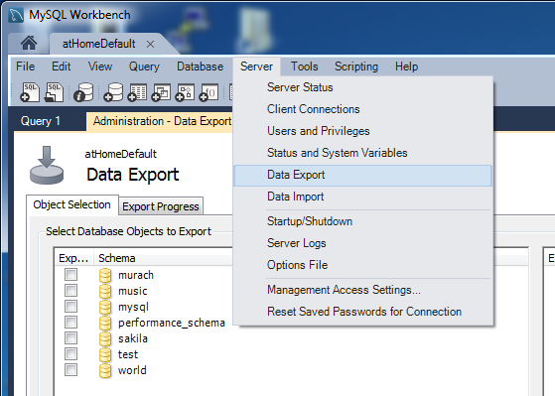

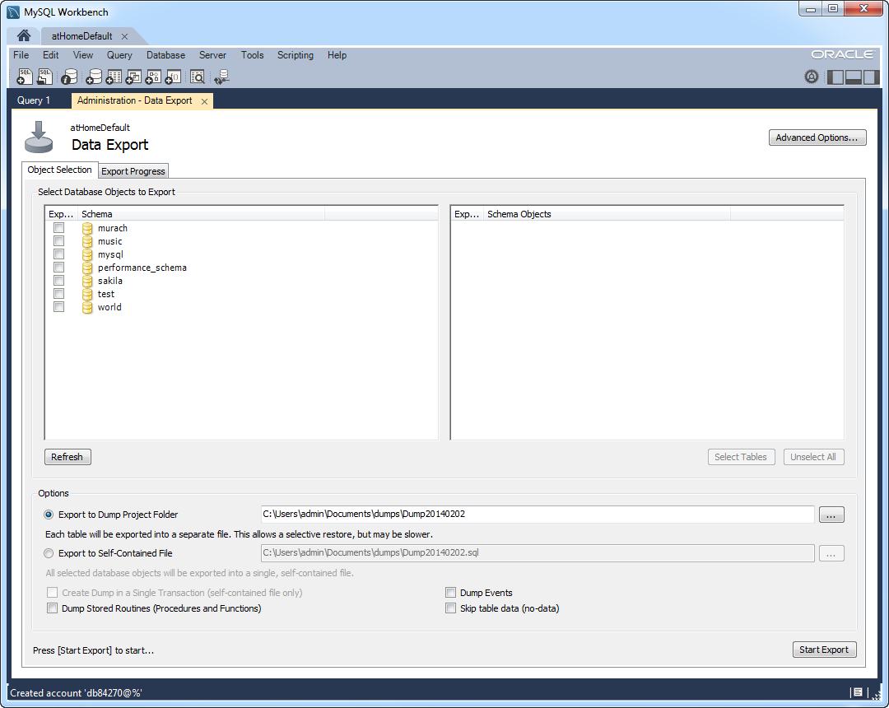

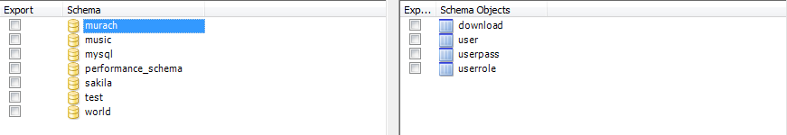

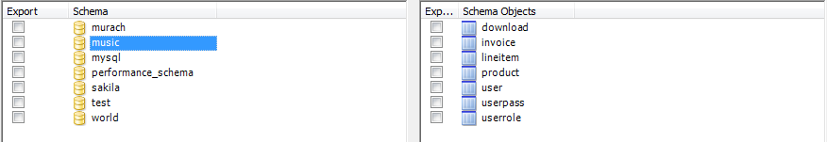

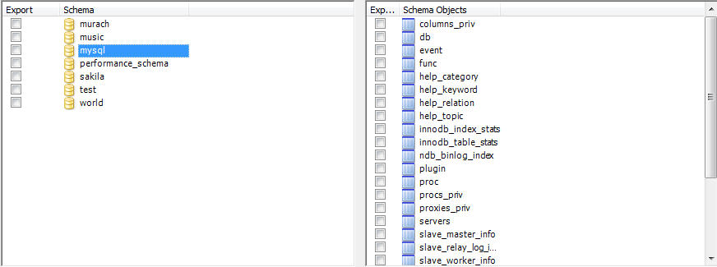



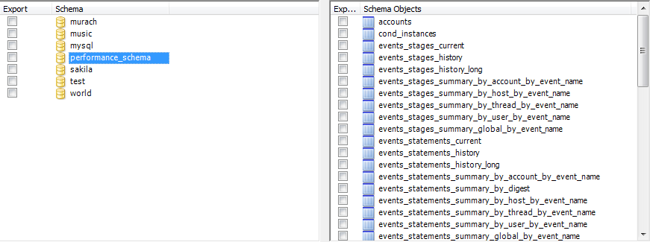

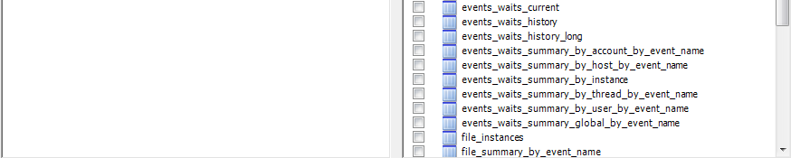





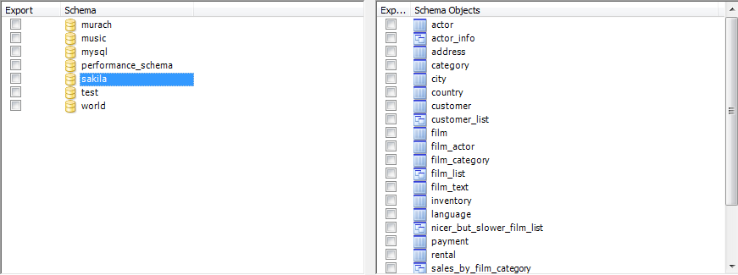



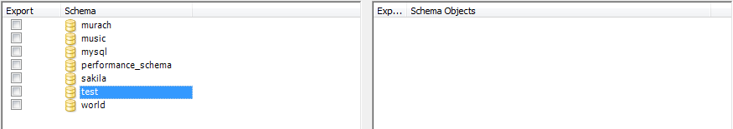

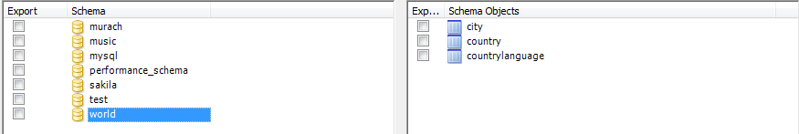

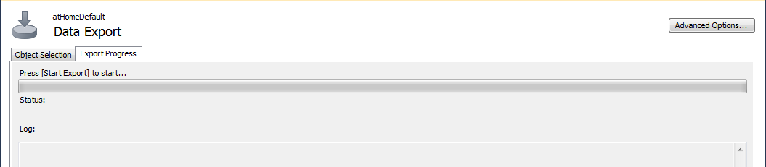

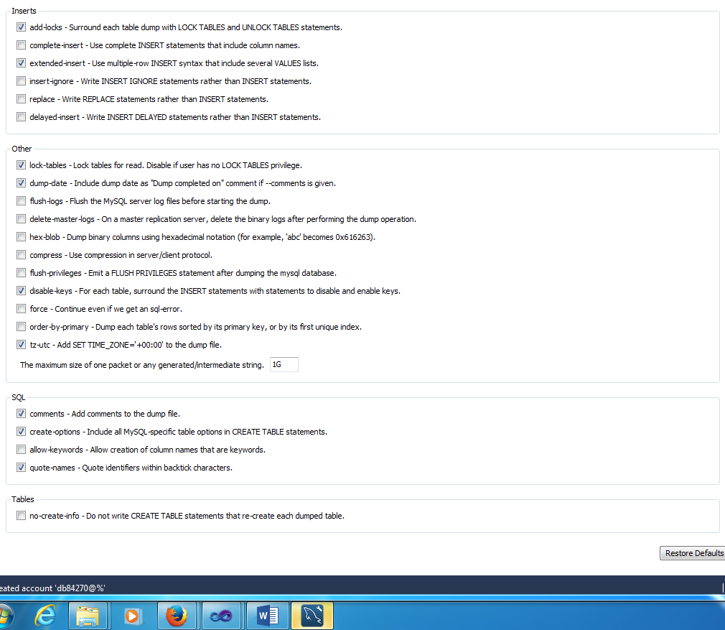

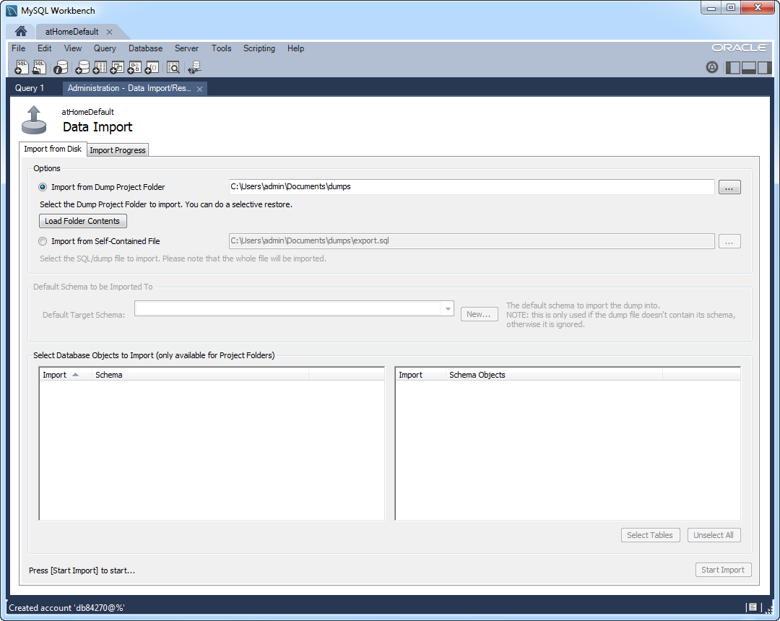

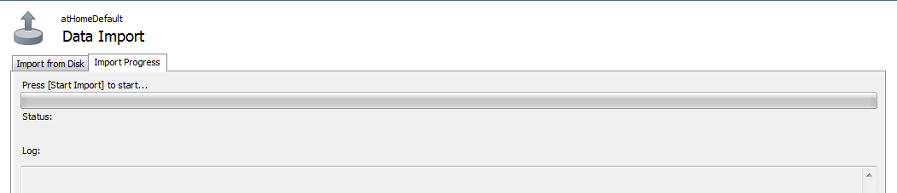

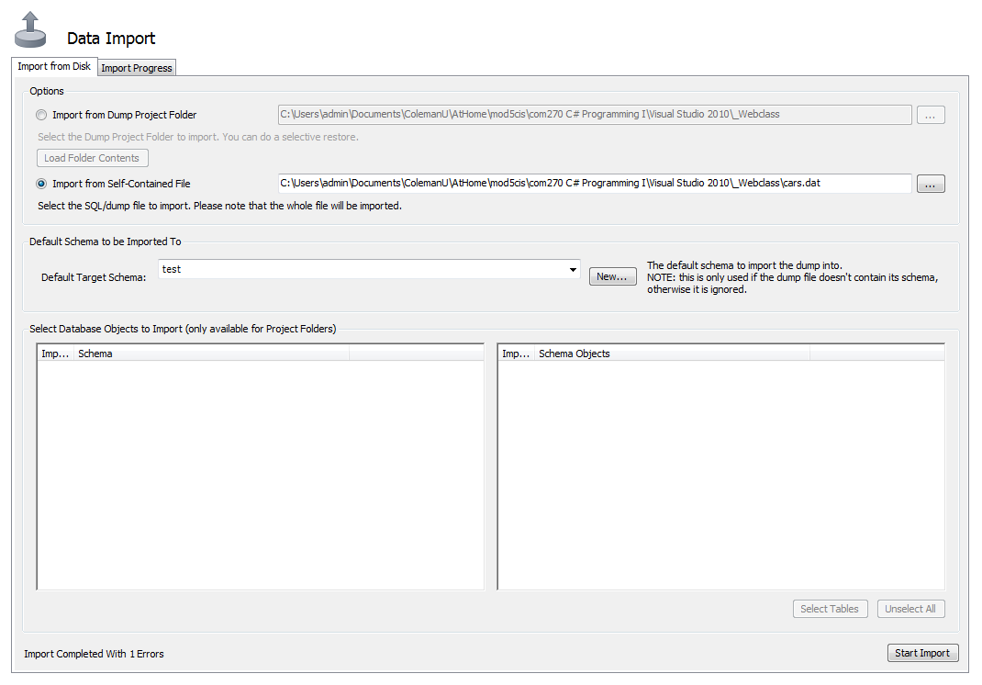

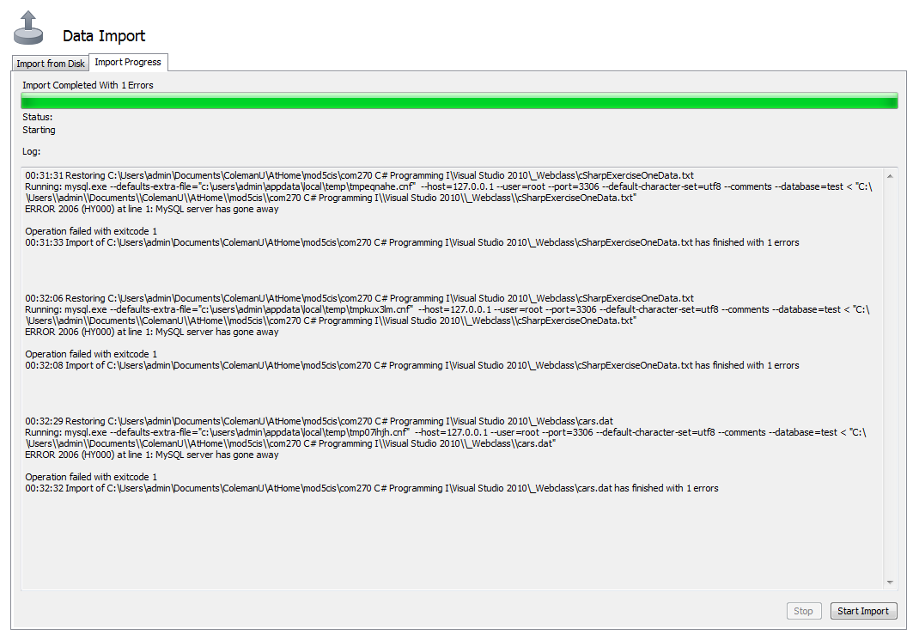

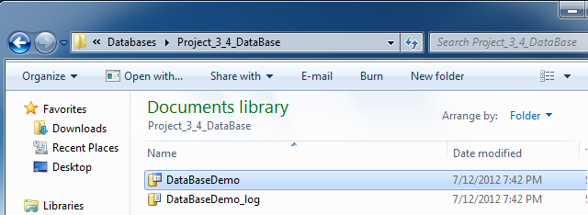

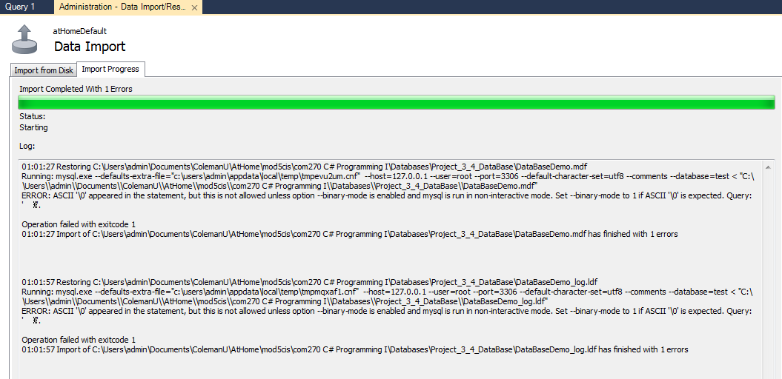

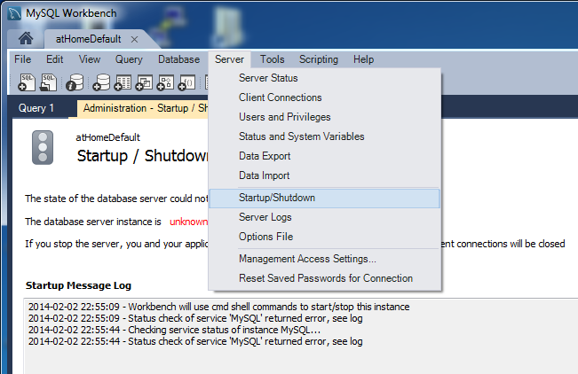

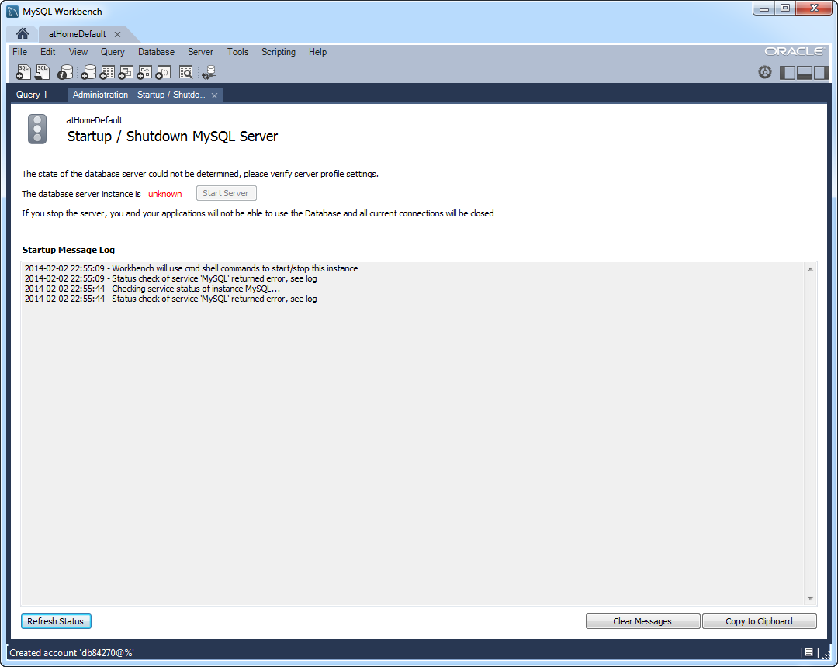

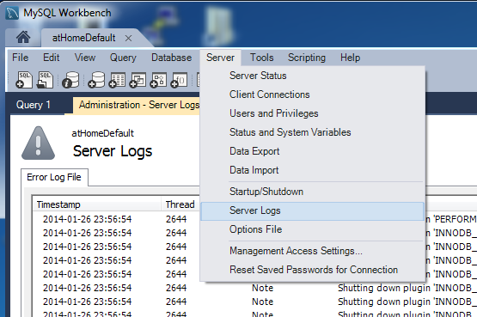

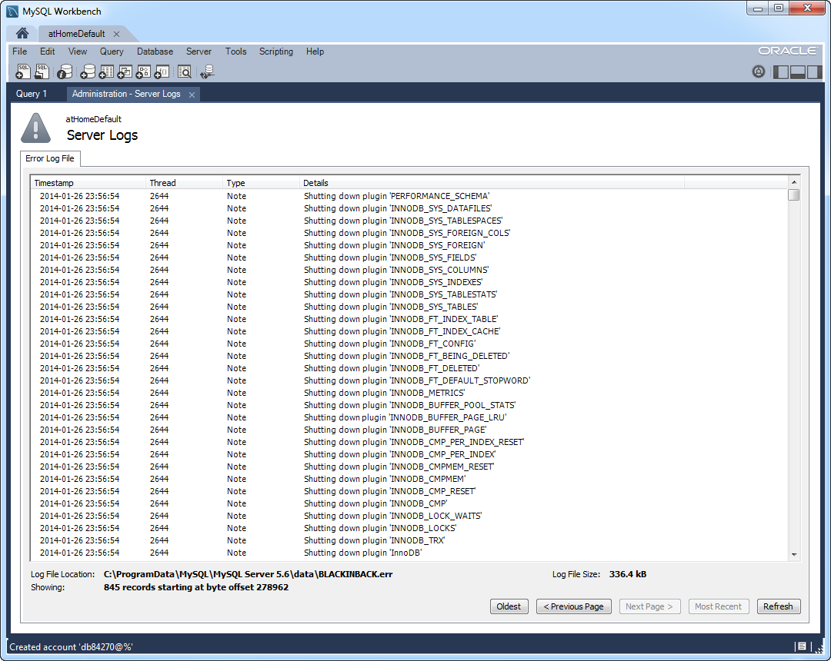

Timestamp, Thread, Type, Details

2014-02-02 10:24:21, 2368, Note, C:/Program Files (x86)/Canon/Easy-WebPrint EX/bin\mysqld: Normal shutdown

2014-02-02 10:24:23, 2368, Note, Giving 0 client threads a chance to die gracefully

2014-02-02 10:24:24, 2368, Note, Event Scheduler: Purging the queue. 0 events

2014-02-02 10:24:24, 2368, Note, Shutting down slave threads

2014-02-02 10:24:25, 2368, Note, Forcefully disconnecting 0 remaining clients

2014-02-02 10:24:26, 2368, Note, Binlog end

2014-02-02 10:24:28, 2368, Note, Shutting down plugin 'partition'

2014-02-02 10:24:28, 2368, Note, Shutting down plugin 'PERFORMANCE_SCHEMA'

2014-02-02 10:24:28, 2368, Note, Shutting down plugin 'INNODB_SYS_DATAFILES'

2014-02-02 10:24:28, 2368, Note, Shutting down plugin 'INNODB_SYS_TABLESPACES'

2014-02-02 10:24:28, 2368, Note, Shutting down plugin 'INNODB_SYS_FOREIGN_COLS'

2014-02-02 10:24:28, 2368, Note, Shutting down plugin 'INNODB_SYS_FOREIGN'

2014-02-02 10:24:28, 2368, Note, Shutting down plugin 'INNODB_SYS_FIELDS'

2014-02-02 10:24:28, 2368, Note, Shutting down plugin 'INNODB_SYS_COLUMNS'

2014-02-02 10:24:28, 2368, Note, Shutting down plugin 'INNODB_SYS_INDEXES'

2014-02-02 10:24:28, 2368, Note, Shutting down plugin 'INNODB_SYS_TABLESTATS'

2014-02-02 10:24:28, 2368, Note, Shutting down plugin 'INNODB_SYS_TABLES'

2014-02-02 10:24:28, 2368, Note, Shutting down plugin 'INNODB_FT_INDEX_TABLE'

2014-02-02 10:24:28, 2368, Note, Shutting down plugin 'INNODB_FT_INDEX_CACHE'

2014-02-02 10:24:28, 2368, Note, Shutting down plugin 'INNODB_FT_CONFIG'

2014-02-02 10:24:28, 2368, Note, Shutting down plugin 'INNODB_FT_BEING_DELETED'

2014-02-02 10:24:28, 2368, Note, Shutting down plugin 'INNODB_FT_DELETED'

2014-02-02 10:24:28, 2368, Note, Shutting down plugin 'INNODB_FT_DEFAULT_STOPWORD'

2014-02-02 10:24:28, 2368, Note, Shutting down plugin 'INNODB_METRICS'

2014-02-02 10:24:28, 2368, Note, Shutting down plugin 'INNODB_BUFFER_POOL_STATS'

2014-02-02 10:24:28, 2368, Note, Shutting down plugin 'INNODB_BUFFER_PAGE_LRU'

2014-02-02 10:24:28, 2368, Note, Shutting down plugin 'INNODB_BUFFER_PAGE'

2014-02-02 10:24:28, 2368, Note, Shutting down plugin 'INNODB_CMP_PER_INDEX_RESET'

2014-02-02 10:24:28, 2368, Note, Shutting down plugin 'INNODB_CMP_PER_INDEX'

2014-02-02 10:24:28, 2368, Note, Shutting down plugin 'INNODB_CMPMEM_RESET'

2014-02-02 10:24:28, 2368, Note, Shutting down plugin 'INNODB_CMPMEM'

2014-02-02 10:24:28, 2368, Note, Shutting down plugin 'INNODB_CMP_RESET'

2014-02-02 10:24:28, 2368, Note, Shutting down plugin 'INNODB_CMP'

2014-02-02 10:24:28, 2368, Note, Shutting down plugin 'INNODB_LOCK_WAITS'

2014-02-02 10:24:28, 2368, Note, Shutting down plugin 'INNODB_LOCKS'

2014-02-02 10:24:28, 2368, Note, Shutting down plugin 'INNODB_TRX'

2014-02-02 10:24:28, 2368, Note, Shutting down plugin 'InnoDB'

2014-02-02 10:24:29, 2368, Note, InnoDB: FTS optimize thread exiting.

2014-02-02 10:24:29, 2368, Note, InnoDB: Starting shutdown...

2014-02-02 10:24:37, 2368, Note, InnoDB: Shutdown completed; log sequence number 8808586

2014-02-02 10:24:37, 2368, Note, Shutting down plugin 'BLACKHOLE'

2014-02-02 10:24:37, 2368, Note, Shutting down plugin 'ARCHIVE'

2014-02-02 10:24:37, 2368, Note, Shutting down plugin 'MRG_MYISAM'

2014-02-02 10:24:37, 2368, Note, Shutting down plugin 'MyISAM'

2014-02-02 10:24:37, 2368, Note, Shutting down plugin 'MEMORY'

2014-02-02 10:24:37, 2368, Note, Shutting down plugin 'CSV'

2014-02-02 10:24:37, 2368, Note, Shutting down plugin 'sha256_password'

2014-02-02 10:24:37, 2368, Note, Shutting down plugin 'mysql_old_password'

2014-02-02 10:24:37, 2368, Note, Shutting down plugin 'mysql_native_password'

2014-02-02 10:24:37, 2368, Note, Shutting down plugin 'binlog'

2014-02-02 10:24:38, 2368, Note, C:/Program Files (x86)/Canon/Easy-WebPrint EX/bin\mysqld: Shutdown complete

2014-02-02 13:54:32, 2364, Note, Plugin 'FEDERATED' is disabled.

2014-02-02 13:54:33, 2364, Warning, option 'innodb-autoextend-increment': unsigned value 67108864 adjusted to 1000

, , , 2014-02-02 13:54:33 984 InnoDB: Warning: Using innodb_additional_mem_pool_size is DEPRECATED. This option may be removed in future releases, together with the option innodb_use_sys_malloc and with the InnoDB's internal memory allocator.

2014-02-02 13:54:33, 2364, Note, InnoDB: The InnoDB memory heap is disabled

2014-02-02 13:54:33, 2364, Note, InnoDB: Mutexes and rw_locks use Windows interlocked functions

2014-02-02 13:54:33, 2364, Note, InnoDB: Compressed tables use zlib 1.2.3

2014-02-02 13:54:33, 2364, Note, InnoDB: Not using CPU crc32 instructions

2014-02-02 13:54:33, 2364, Note, InnoDB: Initializing buffer pool, size = 69.0M

2014-02-02 13:54:33, 2364, Note, InnoDB: Completed initialization of buffer pool

2014-02-02 13:54:33, 2364, Note, InnoDB: Highest supported file format is Barracuda.

2014-02-02 13:54:39, 2364, Note, InnoDB: 128 rollback segment(s) are active.

2014-02-02 13:54:39, 2364, Note, InnoDB: Waiting for purge to start

2014-02-02 13:54:39, 2364, Note, InnoDB: 5.6.14 started; log sequence number 8808586

2014-02-02 13:54:39, 2364, Note, Server hostname (bind-address): '*'; port: 3306

2014-02-02 13:54:41, 2364, Note, IPv6 is available.

2014-02-02 13:54:41, 2364, Note, - '::' resolves to '::';

2014-02-02 13:54:41, 2364, Note, Server socket created on IP: '::'.

2014-02-02 13:54:44, 2364, Note, Event Scheduler: Loaded 0 events

2014-02-02 13:54:44, 2364, Note, C:/Program Files (x86)/Canon/Easy-WebPrint EX/bin\mysqld: ready for connections.

, , , Version: '5.6.14' socket: '' port: 3306 MySQL Community Server (GPL)

2014-02-02 15:11:18, 2364, Note, C:/Program Files (x86)/Canon/Easy-WebPrint EX/bin\mysqld: Normal shutdown

2014-02-02 15:11:18, 2364, Note, Giving 0 client threads a chance to die gracefully

2014-02-02 15:11:18, 2364, Note, Event Scheduler: Purging the queue. 0 events

2014-02-02 15:11:18, 2364, Note, Shutting down slave threads

2014-02-02 15:11:18, 2364, Note, Forcefully disconnecting 0 remaining clients

2014-02-02 15:11:18, 2364, Note, Binlog end

2014-02-02 15:11:19, 2364, Note, Shutting down plugin 'partition'

2014-02-02 15:11:19, 2364, Note, Shutting down plugin 'PERFORMANCE_SCHEMA'

2014-02-02 15:11:19, 2364, Note, Shutting down plugin 'INNODB_SYS_DATAFILES'

2014-02-02 15:11:19, 2364, Note, Shutting down plugin 'INNODB_SYS_TABLESPACES'

2014-02-02 15:11:19, 2364, Note, Shutting down plugin 'INNODB_SYS_FOREIGN_COLS'

2014-02-02 15:11:19, 2364, Note, Shutting down plugin 'INNODB_SYS_FOREIGN'

2014-02-02 15:11:19, 2364, Note, Shutting down plugin 'INNODB_SYS_FIELDS'

2014-02-02 15:11:19, 2364, Note, Shutting down plugin 'INNODB_SYS_COLUMNS'

2014-02-02 15:11:19, 2364, Note, Shutting down plugin 'INNODB_SYS_INDEXES'

2014-02-02 15:11:19, 2364, Note, Shutting down plugin 'INNODB_SYS_TABLESTATS'

2014-02-02 15:11:19, 2364, Note, Shutting down plugin 'INNODB_SYS_TABLES'

2014-02-02 15:11:19, 2364, Note, Shutting down plugin 'INNODB_FT_INDEX_TABLE'

2014-02-02 15:11:19, 2364, Note, Shutting down plugin 'INNODB_FT_INDEX_CACHE'

2014-02-02 15:11:19, 2364, Note, Shutting down plugin 'INNODB_FT_CONFIG'

2014-02-02 15:11:19, 2364, Note, Shutting down plugin 'INNODB_FT_BEING_DELETED'

2014-02-02 15:11:19, 2364, Note, Shutting down plugin 'INNODB_FT_DELETED'

2014-02-02 15:11:19, 2364, Note, Shutting down plugin 'INNODB_FT_DEFAULT_STOPWORD'

2014-02-02 15:11:19, 2364, Note, Shutting down plugin 'INNODB_METRICS'

2014-02-02 15:11:19, 2364, Note, Shutting down plugin 'INNODB_BUFFER_POOL_STATS'

2014-02-02 15:11:19, 2364, Note, Shutting down plugin 'INNODB_BUFFER_PAGE_LRU'

2014-02-02 15:11:19, 2364, Note, Shutting down plugin 'INNODB_BUFFER_PAGE'

2014-02-02 15:11:19, 2364, Note, Shutting down plugin 'INNODB_CMP_PER_INDEX_RESET'

2014-02-02 15:11:19, 2364, Note, Shutting down plugin 'INNODB_CMP_PER_INDEX'

2014-02-02 15:11:19, 2364, Note, Shutting down plugin 'INNODB_CMPMEM_RESET'

2014-02-02 15:11:19, 2364, Note, Shutting down plugin 'INNODB_CMPMEM'

2014-02-02 15:11:19, 2364, Note, Shutting down plugin 'INNODB_CMP_RESET'

2014-02-02 15:11:19, 2364, Note, Shutting down plugin 'INNODB_CMP'

2014-02-02 15:11:19, 2364, Note, Shutting down plugin 'INNODB_LOCK_WAITS'

2014-02-02 15:11:19, 2364, Note, Shutting down plugin 'INNODB_LOCKS'

2014-02-02 15:11:19, 2364, Note, Shutting down plugin 'INNODB_TRX'

2014-02-02 15:11:19, 2364, Note, Shutting down plugin 'InnoDB'

2014-02-02 15:11:20, 2364, Note, InnoDB: FTS optimize thread exiting.

2014-02-02 15:11:20, 2364, Note, InnoDB: Starting shutdown...

2014-02-02 15:11:25, 2364, Note, InnoDB: Shutdown completed; log sequence number 8808596

2014-02-02 15:11:25, 2364, Note, Shutting down plugin 'BLACKHOLE'

2014-02-02 15:11:25, 2364, Note, Shutting down plugin 'ARCHIVE'

2014-02-02 15:11:25, 2364, Note, Shutting down plugin 'MRG_MYISAM'

2014-02-02 15:11:25, 2364, Note, Shutting down plugin 'MyISAM'

2014-02-02 15:11:25, 2364, Note, Shutting down plugin 'MEMORY'

2014-02-02 15:11:25, 2364, Note, Shutting down plugin 'CSV'

2014-02-02 15:11:25, 2364, Note, Shutting down plugin 'sha256_password'

2014-02-02 15:11:25, 2364, Note, Shutting down plugin 'mysql_old_password'

2014-02-02 15:11:25, 2364, Note, Shutting down plugin 'mysql_native_password'

2014-02-02 15:11:25, 2364, Note, Shutting down plugin 'binlog'

2014-02-02 15:11:26, 2364, Note, C:/Program Files (x86)/Canon/Easy-WebPrint EX/bin\mysqld: Shutdown complete

2014-02-02 20:14:12, 2196, Note, Plugin 'FEDERATED' is disabled.

2014-02-02 20:14:12, 2196, Warning, option 'innodb-autoextend-increment': unsigned value 67108864 adjusted to 1000

, , , 2014-02-02 20:14:12 8d4 InnoDB: Warning: Using innodb_additional_mem_pool_size is DEPRECATED. This option may be removed in future releases, together with the option innodb_use_sys_malloc and with the InnoDB's internal memory allocator.

2014-02-02 20:14:12, 2196, Note, InnoDB: The InnoDB memory heap is disabled

2014-02-02 20:14:12, 2196, Note, InnoDB: Mutexes and rw_locks use Windows interlocked functions

2014-02-02 20:14:12, 2196, Note, InnoDB: Compressed tables use zlib 1.2.3

2014-02-02 20:14:12, 2196, Note, InnoDB: Not using CPU crc32 instructions

2014-02-02 20:14:12, 2196, Note, InnoDB: Initializing buffer pool, size = 69.0M

2014-02-02 20:14:12, 2196, Note, InnoDB: Completed initialization of buffer pool

2014-02-02 20:14:13, 2196, Note, InnoDB: Highest supported file format is Barracuda.

2014-02-02 20:14:26, 2196, Note, InnoDB: 128 rollback segment(s) are active.

2014-02-02 20:14:27, 2196, Note, InnoDB: Waiting for purge to start

2014-02-02 20:14:27, 2196, Note, InnoDB: 5.6.14 started; log sequence number 8808596

2014-02-02 20:14:27, 2196, Note, Server hostname (bind-address): '*'; port: 3306

2014-02-02 20:14:28, 2196, Note, IPv6 is available.

2014-02-02 20:14:28, 2196, Note, - '::' resolves to '::';

2014-02-02 20:14:28, 2196, Note, Server socket created on IP: '::'.

2014-02-02 20:14:31, 2196, Note, Event Scheduler: Loaded 0 events

2014-02-02 20:14:31, 2196, Note, C:/Program Files (x86)/Canon/Easy-WebPrint EX/bin\mysqld: ready for connections.

, , , Version: '5.6.14' socket: '' port: 3306 MySQL Community Server (GPL)

